Short term plan: term 2
Unit 3: Treasure and heritage |  | Lesson 18
Teacher name:

Date:
Grade: 4 |  | Number present: | absent:
Lesson title | Treasure and numbers1
Learning objectives | 4.4.1.1 plan, write and check sentences with support on a range of basic personal, general and some curricular topics  4.​4.​7.​1 spell most familiar high-frequency words accurately when writing independently;  4.5.2.1 use cardinal numbers 1 -1000 and ordinal numbers 1 – 100
Value links | Loyalty – Loyalty might be a core personal value to you if you highly prize friends that are reliable and trustworthy. You might put your friends or chosen family first, always being there for them when they need you.
Lesson objectives | Learners will be able to:  - learn about numbers  - talk about location
Plan

Stages / Time | Teachers actions | Students actions | Assessment criteria | Resources
Beginning of the lesson  Warming-up  3 min  Pre-learning  «Brainstorming» method  7 min. | Organization moment :  1.Greeting.  Ask about the weather.  The teacher sets the lesson objectives, letting students know what to anticipate from the lesson.  Warming up  Where are you from?  How old are you?  What color is it?  How many students are there in class?  What day of the week today?  Ask a few pupils to stand up and stand in a row. Ask the rest of the class questions to revise the ordinals.  Lead – In  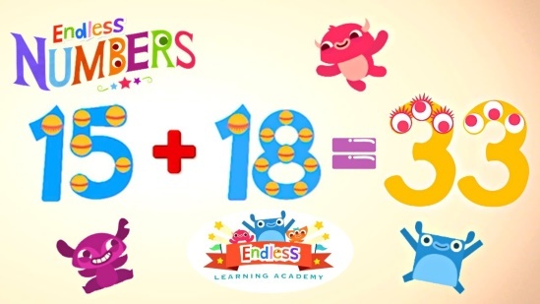 | The aim: To develop pupils speaking skills and create friendly atmosphere  Efficiency: By wishing each other they feel better and feel the support of others  Students of the class are listed.  Students' attention is drawn to the lesson.  Determines the topic and purpose of the lesson  •Learners remember previous lesson vocabulary  Students say different words from the picture  Answer the question. | The teacher to assess learners for their ability.  “Good job!  Well done!”  Formative Assessment  Good job!  Descriptor:  - know daily routines vocabulary  - know prepositions of place  Point 1  Assessment criteria  - Learners have met the learning objectives if they can talk about numbers and location; | Pictures  worksheet  Student’s book
Middle of the lesson  Presentation part.  30 min | Ex:3 P:38  • Put the flashcards up on the board. Point to the numbers, one at a time, and say the corresponding words. The pupils repeat chorally and/or individually. Point to the numbers in random order and ask individual pupils to name them. Ask the rest of the class for verification.  Ex: 4 P: 38  • Write the following sums on the board. Read aloud the sums and draw the pupils' attention to the names of the symbols (+ plus, - minus, x times, = equals).  1+1=2 (one plus one equals two)  2-1-1 (two minus 1 equals one)  2x2-4 (two times two equals four)  • Read the sum in the example and ask the pupils to give you the solution orally. Ask them to point to the correct number on the map. Explain that the solutions to the problems is one of the numbers on the map. Then refer them to the number written in letters in the model and explain the activity. Allow the pupils some time to complete it. Check their answers.  Ex: 5 P: 39  • Put your pencil on the left of a book, show it to the class and ask: Where is the pencil? Answer: It's on the left of the book. Write the exchange on the board and underline the words in bold. The pupils repeat, chorally and/or individually. Follow the same procedure and present the rest of the prepositions.  Drill your pupils:  • Go through the Study spot section briefly. Read the instructions and explain the activity. Allow the pupils some time to read the sentences and underline the correct prepositions. Check their answers. | • Pupils listen, point and repeat. Then match  ANSWERS  2 E  3 C  4 D  5 A  • Pupils find Captain Jack Parrot's treasure! Do the sums and cross off the places on the map. The last place is where the treasure is.  ANSWERS  2 six hundred  3 five hundred and forty  4 eight hundred and thirty  5 six hundred and ninety  6 one thousand  The treasure is at 1,000.  • Pupils look, read and underline  ANSWERS  2 right  3 between  4 right  5 on the left of | Descriptor:  - point to each flashcard  - ask individual pupils to name them  Total: 2 point  pupils are evaluated by collecting fish  Descriptor:  - know the numbers  - can do the sums  -complete the sentences  Total: 2 point  Descriptor:  -can use grammar structure  - can choose the correct option according to the listening  Total: 1 point  Self assessment  -Make CCQ questions Yes / No  Total: 10 point | Card  Worksheet  Students book
End of the lesson  5 min | FEEDBACK  Learners provide feedback on what they have learned at the lesson.  Ex: P:  Home task:  Write the days | 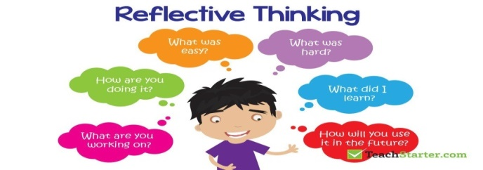 |  | Poster Success

