Short term lesson plan
World Literature. CLIL
КГУ «Школа-гимназия №20 имени Титова»
Учитель английского языка Чернышева Л.А.
Разработка плана урока по английскому языку для 9 класса
Unit 5 Lesson plan 55 |  |  | School: №20
Date: |  |  | Teacher’s name: Chernysheva L.A
Class: 9 |  |  | Number present: | Number absent:
Lesson title |  |  | World Literature. CLIL
Learning objectives(s) that this lesson is contributing to |  | 9.C1 use speaking and listening skills to solve problems creatively and cooperatively in groups  9.L7 recognise typical features at word, sentence and text level of a range of spoken genres  9.C8 develop intercultural awareness through reading and discussion  9.S7 use appropriate subject-specific vocabulary and syntax to talk about an increased curricular topics  9.R5 deduce meaning from context in short texts on a limited range of familiar general and curricular topics
Lesson objectives |  | All learners will be able to:  - Identify new words and use them as the basis for discussion.  - Demonstrate knowledge of usage of the Past tenses.  Most learners will be able to:  - Select, compile, and synthesize information for an oral presentation  - Provide a point of view in conversations and discussions;  Some learners will be able to:  - Respond to and discuss the reading passage using interpretive, evaluative and creative thinking skills.  - Make a presentation about famous poets. Respond to and discuss the reading passage using interpretive, evaluative and creative thinking skills..
Value links |  | Cooperation, respect each other's opinion, functional literacy.
Cross curr links |  | Literature, Social Science, Psychology, Information Technology, Art.
Previous learning |  | Talking about Abay Kunanbayuly
Plan
Planned timings | Planned activities |  |  |  | Resources
Beginning the lesson  5 min. | The lesson greeting.  The teacher sets the lesson objectives, letting students know what to anticipate from the lesson.  Warm up. Free talk.  - A teacher asks learners to discuss in groups what they remember about a famous Kazakh writer and poet from a previous lesson. Learners draw a Mind Map on a board by adding the facts of his biography in turn.  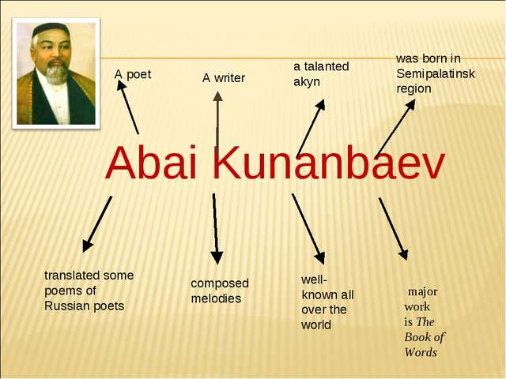  - What other famous poets in the world do you know? Teacher elicits the names of other writers and writes them on the board |  |  |  | Pictures  PPT  Pictures  Mind Map
Main  Activities  15 min.  15 min. | - Group work. Jigsaw activity.  Learners work in 3 groups. Each group reads the text about a biography of one of the outstanding poets.  Group 1: William Shakespeare  William Shakespeare, the greatest of English writers, and probably the greatest playwright who has ever lived, was born in 1564, in Stratford-on-Avon.  His father, John Shakespeare, was a glove-maker, and when he fell into debt, William had to help him in the trade.  When Shakespeare was twenty-one, he went to London. There is a story that Shakespeare's first job in London was holding rich men's horses at the theatre door. Later, Shakespeare became an actor and a member of a very successful acting company.  Very soon, however, the actors were told that they could no longer use the land that their theatre was built on and the company had nowhere else to perform. There is a story that in one night the whole acting troop took down their theatre, timber by timber, brick by brick. They carried it across the river and rebuilt it. The new theatre was called the Globe.  Shakespeare's Globe was rather different from modern theatres. The plays were performed in the open air and the audience got wet if it rained. Women in those days weren't allowed to act in public and all the parts (even Juliet!) were played by men.  Shakespeare wrote 37 plays: 10 tragedies (such as Hamlet, King Lear, Othello, Macbeth), 17 comedies (such as As You Like It, Twelfth Night, Much Ado About Nothing), 10 historical plays (such as Henry IV, Richard III.). He also left 7 books of poems.  Most of Shakespeare's plays were not published in his lifetime. So some of them may have been lost in the fire when the Globe burnt down in 1613.  Shakespeare spent the last years of his life at Stratford, where he died, ironically, on the same date as his birthday, the 23d of April, 1616. He was buried in the church of Stratford. A monument was erected to the memory of the great playwright in the Poet's Corner in Westminster Abbey.  Group 2: Alexander Pushkin  Alexander Pushkin was born in 1799, in Moscow. His father was a retired major. His mother was a descendant of an African lord. But by the time Alexander was born, the family had lost their wealth and influence.  Pushkin entered the Tsarskoye Selo Lyceum - a special school for privileged children of the nobility. Pushkin was not a very good student in most subjects, but he performed brilliantly in French and Russian literature. At school he wrote about 130 poems. He published his first poem at the age of 15.  After graduating from the Lyceum, Pushkin was appointed to the Collegium of Foreign Affairs in the rank of collegiate secretary, where he did not work even a day, devoting himself entirely to creativity. His political verses associated him with the Decembrist revolt, causing him to be banished in 1820. Pushkin spent the years in various places in the southern part of Russia, including the Caucasus and in the Crimea. Then he moved to Mikhailovskoye, an estate owned by his family.  Pushkin lived there alone with the family nurse. At that time the nurse told Pushkin many folk tales, which were shown in many of his poems. He wrote Eugene Onegin, composed the tragedy Boris Godunov, and many important lyrics. His other works are Ruslan and Ludmilla, The Queen of Spades, Boris Godunov, The Golden Cockerel. In 1831 Pushkin married Natalya Nikolayevna Goncharova and settled in St. Petersburg. She bore him three children. Pushkin was mortally wounded defending his wife’s honour in a duel with d’Anthès. He died on 29 January at aged 37.  Pushkin was interested in world literature, in such English writers as William Shakespeare, Lord Byron, Sir Walter Scott.  Group 1: Abay Kunanbaiuly  Abay Kunanbaiuly is the Kazakhstan’s best- known writer, poet, translator, composer and philosopher. He was born near Semipalatinsk in 1845, at a time when literature was becoming an important art form across the world. For his secondary education, he went to a religious school where he studied Oriental classical literature. He also learned a number of languages including Russian, Arabic and Persian, and read Russian authors such as Tolstoy, Dostoyevsky, Pushkin and Turgenev. Abay had a number of talents. He started writing poems when he was only twelve, but at first he did not sign them in his own name. In fact, the first poem he wrote in his own name was Summer, when he was thirty-one. Abay also translated a number of poems from some of the great European poets, such as Goethe, Byron and Pushkin. His translation of Eugene Onegin was one of fifty classic Russian works of literature he translated into Kazakh. People often call him the founder of Kazakh literature. His most famous work, The Book of Words is not a fictional story but a book of his philosophical thoughts about Kazakh life, how people should behave and what makes a wise man or woman. Because of this book, and because of the role he played in the lives of his people, people remember him as a spiritual leader in Kazakhstan.  - Individual work. After discussion learners write a test to summarize their knowledge about outstanding authors.  TEST  Outstanding Writers of All Generations  TASK: Read the texts about the most famous writers in Kazakh, Russian and English literature and answer the questions about Abay Kunanbaiuly, Alexander Pushkin, William Shakespeare.  Grade 9_30 points  Section I: Identify the writers and the facts of their lives.  1. Match the authors with the years of their birth:  1 Abay a 1845  2 Shakespeare b 1564  3 Pushkin c 1799  A) 1c 2b 3a B) 1c 2a 3b C) 1a 2b 3c  2. Match the writers with the towns where they were born:  1 Abay a Moscow  2 Shakespeare b Semipalatinsk  3 Pushkin c Stratford-on-Avon  A) 1b 2a 3c B) 1b 2c 3a C) 1a 2c 3b  3. Match the poets and the schools they finished:  1 Abay a didn’t finish school  2 Shakespeare b a religious school  3 Pushkin c lyceum  A) 1b 2a 3c B) 1a 2c 3b C) 1c 2b 3a  4. What age did the authors publish their first literature works?  1 Abay a 15  2 Shakespeare b 31  3 Pushkin c 30  A) 1c 2b 3a B) 1a 2b 3c C) 1b 2c 3a  5. What languages did the writers speak fluently?  1 Abay a French  2 Shakespeare b Arabic  3 Pushkin c English  A) 1c 2b 3a B) 1a 2b 3c C) 1b 2c 3a  Section II: Choose the correct answer for the multiple-choice questions.  6. This outstanding writer was a composer, a philosopher and a spiritual leader in his country.  A) Shakespeare B) Gomer C) Abay D) Pushkin  7. This famous author lived in the XVI century.  A) Shakespeare B) George Byron C) Pushkin D) Abay  8. This great poet was banished because of his poetry.  A) Walter Scott B) Pushkin C) Abay D) Shakespeare  9. A monument of this great poet is situated in the Poet’s Corner.  A) Abay B) Henry VIII C) Pushkin D) Shakespeare  10. The writer who wrote a book which teaches us how to behave in community.  A) Shakespeare B) Eugene Onegin C) Pushkin D) Abay  11. This famous poet built a theatre of his own.  A) Abay B) Shakespeare C) Pushkin D) Goethe  12. Some valuable works of this author were burnt in the fire.  A) Shakespeare B) Tolstoy C) Pushkin D) Abay  13. The poem Summer was written by…  A) Shakespeare B) Gomer C) Abay D) Pushkin  14. By the time Pushkin was born his family was…  A) rich B) poor C) prosperous D) powerful  15. This author roleplayed in his own plays as an actor.  A) Shakespeare B) Abay C) Pushkin D) Tolstoy  Section III: Find the odd answer.  16. William Shakespeare wrote:  A) tragedies B) comedies C) detective stories D) historical plays  17. Abay Kunanbaiuly knew a lot of foreign languages:  A) Kazakh B) Russian C) Arabic D) Persian  18. Alexander Pushkin wrote:  A) The Tale of the Golden Cockerel  B) The Tale of the Fisherman and the Fish.  C) The Tale of the Dead Princess.  D) The Tale of the Stone Guest  19. Abay was influenced by the number of Russian writers:  A) Pushkin B) Shakespeare C) Tolstoy D) Dostoyevsky  20. A.Pushkin was influenced by…  A) Lord Byron B) Zhukovsky C) Batyushkov D) Shakespeare  Section IV: Find the correct answer True or False  21. Abay wrote the poem Summer when he was 30 years old. True / False  22. Shakespeare wrote 37 tragedies. True / False  23. Abay translated 50 works of literature from Russian into Kazakh. True / False  24. Pushkin died of a serious disease. True / False  25. Pushkin got an excellent education. True / False  26. Shakespeare was buried in the Poet’s Corner. True / False  27. Pushkin was a descendant of African ancestors. True / False  28. Abay translated some poems from English into Kazakh. True / False  29. Pushkin was related to the revolution. True / False  30. Shakespeare’s theater was ruined by the fire. True / False |  |  |  | Worksheet 1  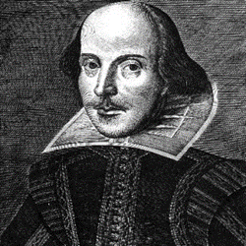  Worksheet 2  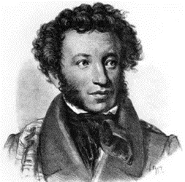  Worksheet 3  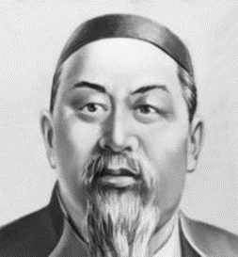  Worksheets 4  Answer Key  of the Test “Outstanding Writers of All Generations”  Grade 9_30 points  1. A  2. B  3. A  4. C  5. C  6. C  7. A  8. B  9. D  10. D  11. B  12. A  13. C  14. B  15. A  16. C  17. A  18. D  19. B  20. C  21. F  22. F  23. T  24. F  25. T  26. F  27. T  28. T  29. T  30. T
Ending the lesson  5 min. | Giving the home task. W.B. p.42, Kazakh writers( a report)  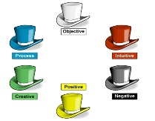  Students express their attitude to the lesson and give self-assessment using the method: “Six thinking hats”:  - Green: How can you use today's learning in different subjects?  - Red: How do you feel about your work today?  - White: What have you leant today?  - Black: What were the weaknesses of your work?  - Blue: How much progress have you made in this lesson? (Now I can, I still need to work on, I've improved in, Today I learnt... )  - Yellow: What did you like about today's lesson?
Differentiation –  how do you plan to give more support? |  |  | Assessment –how are you planning to check learners’ learning? |  |  | Critical thinking
Differentiation can be achieved through the selection of activities, identification of learning outcomes for a certain student, provision of individual support to learners, selection of learning materials and resources based on the individual abilities of learners. |  |  | Assessment criteria:  Identify the main idea in extended talks with little support.  Apply topic related vocabulary in speech appropriately arranging words and phrases into well-formed sentences.  Demonstrate the ability to participate in a conversation.  Descriptor: A learner:  - selects an appropriate answer.  - completes the task.  - uses appropriate subject-specific vocabulary while speaking.  - discusses questions and answers the questions within the group.  - Observation  - Feedback on the work  - Peer-assessment |  |  | Students think critically, exploring, developing, evaluating and making choices about their own and others’ ideas
Reflection
Were the lesson objectives/learning objectives realistic?
Did the learners achieve the LO?
If not, why?
Did my planned differentiation work well?
Did I stick to timings?
What changes did I make from my plan and why?

