Date: 05.05.2022 |  |  | Teacher name: Baitugelova Saltanat
Grade: 2 «В» |  |  | Number present: |  |  | Number absent:
Theme of the lesson: |  | Changing seasons
Learning objectives |  | S.2 ask questions in order to satisfy basic needs and find information in familiar topic  R.3 read and follow with considerable support simple words; phrases and sentences on familiar topics  US.2 use common adjectives in descriptions and to talk about simple feelings
Lesson objectives |  | Learners will be able to:  - understand the text about all seasons and weather;  - describe each season  - recognize the new words and develop writing skills  -locate the adjectives to each characteristics of weather
Criteria |  | Recognize the main information in a short carefully articulated talk on familiar topics  Pronounce seasons vocabulary words carefully  Write seasons with adjective
Previous learning |  | The weather
Plan
Planned timings | Planned activities |  |  | Learners’ activities | Evaluation |  | Resources
Begining  5 min | ORGANIZATIONAL MOMENT  WARMING UP  Greeting. Teacher greets students; students respond to greet and take their places.  Warm-up  Method: Describing pictures  Teacher shows learners at the board 4 seasons picture. They describe what did they see?  Look at the picture: here are our new words:  Then teacher shows new words with picture and ask learners repeat after her.  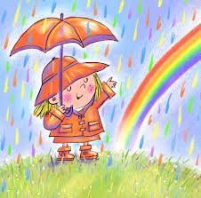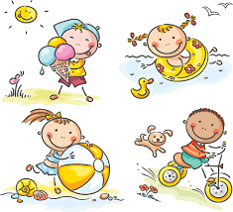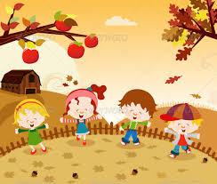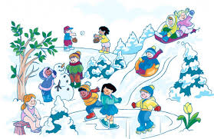 Spring Summer Autumn Winter  Write down to your vocabulary.  Let’s describe seasons by their colours:  Spring is green  Summer is bright  Autumn is yellow  Winter is white |  |  | Greeting  Learners describe the picture | Very fine! Repeat it one more time.  Let’s do it together!  Your pronunciation is very good! |  | Pictures of 4 seasons
Middle  30 min | INTRODUCTION  Activity 1.  Teacher gives learners worksheets and explain them what to do.  Then leaners do reading task: Read and understand the meaning of the text. And answer the questions to each other.  Method: “Read loudly and check” students should read loudly and check themselves what they understood? This method helps for expressive reading and speaking skills.  The text: “ Seasons”  There are four seasons. Winter, spring, summer and autumn are the seasons of the year. Winter .This cold, usually it snows. The days are short and the nights are long. After winter is spring. It is a very nice season. After spring is summer. It is the hottest season. There are many nice flowers in the parks. After summer is autumn. The weather is changeable.  Questions:  - How many seasons are there in a year?  - What are they?  - What is the weather like in winter?  - What season is after winter?  - What is the weather like in spring?  - Do you like autumn?  - What is the hottest season?  Descriptor Learners  - Read and understand the text  - Answer the questions  - Retell the text  Feedback: “Two stars, a wish”  Teacher makes comments on good work of the students. They did good work in answering the questions, shared their opinion, and pay attention to pronunciation.  Activity 2  Learners have to look at examples then they do it following instruction. Then learners take adjectives which describe the weather and match with the pictures  Method “Matching the words”. This method helps to student to think very widely.  Cold hot cloudy rainy sunny snowy windy foggy  cold sunny rainy cloudy windy snowy foggy hot  Descriptor A learner  Read the words  Match with the pictures |  |  | Learners do the tasks  Learners answer to the questions  Learners follow the instructions | Verbal evaluation  Individual avaluation  Mutual avaluation  “That’s great job! You did it!”.  You confused the word foggy, but can write without mistakes. |  | PPT  http://www.freekidsb  ooks.org
End  5 min | FEEDBACK  Learners give reflection for today’s lesson by answering the teachers question to oral form;  -Did you like today’s lesson ?  -What do you know about seasons? Can you name seasons?  -Do you know colours of seasons?  I gave smiles for their write answers  Self-assessment  Saying goodbye |  |  | Learners answer to the questions | Self-assessment |  | cards  Images of smiles

