LESSON: The two giants |  |  | School:Ekiasha secondary school
Date: 18.02.2021 |  |  | Teacher name: Dogomanova T.T

CLASS: 5b
Learning objectives(s) that this lesson is contributing to |  | 5.4.9.1 to understand the main event of the story by the text  5.3.3.1 to develop speaking, reading abilities  5.5.6.1 to use linkers join in speaking
Lesson objectives |  | All learners will be able to:
- understand the main events in the story
- say thank you and give reasons
 |  | Most learners will be able to:
- read the story without support
- understand the moral of the story
- make some questions on the given story
 |  | Some learners will be able to:
- understand most of the language in the story
- answer the questions and give examples from the text
Language objectives |  | Use vocabulary from the story to answer the questions
Value links |  | Respect for self and others, academic honesty, Cooperation
Cross  Curricular  links |  | Literature
ICT skills |  | Projector or Smart board for presenting pictures
Previous learning |  | The pearl of Kazakhstan
Plan
Planned timings | Planned activities |  |  | Resources
Beginning  0-3  Middle  8-12  12-17  18-21 | Greeting:  Good day my dear st!  How are you?  Are you rady for the lesson?  Nou let’s start our lesson OK  What was your H/T  Ex6. p 81  Use the synonyms form ex.6 a) p 81 to complete summary of the ‘Pearl of Kazakhstan’  - high-tall  - clear-clean  - huge-very big  - beautiful-pretty  - cheeky-naughty  - wise-very clever  - happy-glad  FA: Teacher assesses orally  Association line of the words  Strategy: Who knows?  Presentation new theme the legend about dombra «The two giants » by asking questions:  -MP3. how do you think what musical instrument is it?  -What does it look like?  -What do you know about dombra?  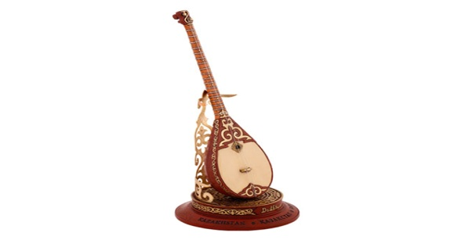  Strategy video promt: The two giants  Pre-reading task: Study program: Quizlet :  The quick vocabulary. Show and listen from quizlet a list of new words from the story and they together read it  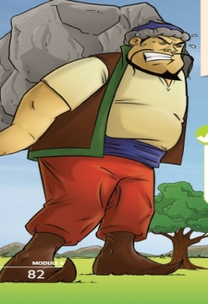  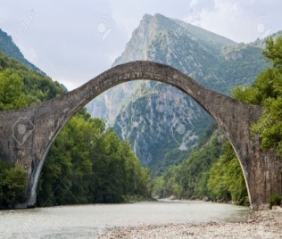  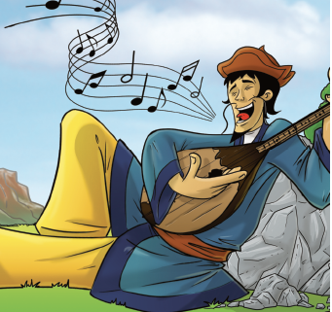  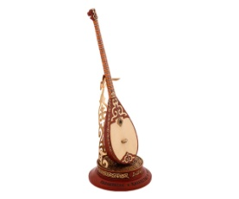  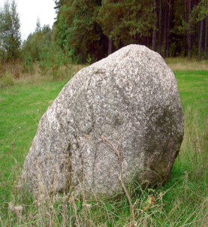  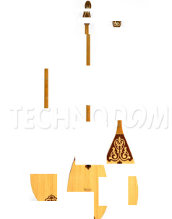  Wood |wʊd| ағаш  String |strɪŋ| шек  Stone |stəʊn| тас  Silly |sɪli| ақымақ  Rock |rɒk| жар, тас  Hit |hɪt| ұру  Reading:  Answer the questions  Surprised from the box  Every fire has got a task. The pupils  must read and give the translations  and opinions.  Strategy: Cinquain  Presentation of the heroes.  Make up a presentation about the positive and negative qualities of the hero and present this hero to the class.  The first sentence-noun  The second sentence-two adjectives  The third sentence-three verbs  The fourth sentence- one sentence (The clause must be complemented by a single idea)  The fifth sentence-Synonym of the first sentence  Descriptor  -correctly writing of the words  -right grammatically structure of the sentence  -correctly reading the words and the sentence  Ex5 p 83 complete the sentence. Use :played ,made,gave, carried,got,smashed |  |  | audio  video  Quizlet.com  pictures
Test. Check your knowledge
Keys to the text
1.b) 2.b) 3.c) 4. a) 5. c)
rammar

End  38-40 | Reflection: /Dombra/  The pupils must speak about the event of the story using linkers join:  At the end of the lesson learners reflect on  What they have learned?  What remained unclear for the them?  What they continue working on ? |  |  | Stickers

