Summative assessment for the unit “Our Neighbourhood”
Term 4, grade 6

Learning objectives:
6.L5 Understand most specific information and detail of supported, extended talk on a range general and curricular topics
6.S1 Understand short, supported narratives on an increasing range of general and some curricular topics
6.R8 Use independently familiar paper and digital reference resources to check meaning and extend understanding
Assessment criteria
• Respond to questions on an increasing range of general and some curricular topics
• Write factual ways to different places.

Task 1. Read the text and answer the questions

My Ideal Place to Live
My ideal place to live is in a small town in the countryside. My house isn’t too small and it isn’t too big. Downstairs, there is large living room with a huge, modern TV where the whole family can relax. My bedroom is upstairs and it has a great view of our beautiful garden. My ideal neighbourhood has got tree-lined streets and parks, but it also has shops and a few lively places like a cinema and a cool café to hang out with my friends. There is a baker's nearby so we can buy fresh bread every morning. The local people are friendly and don’t mind helping each other out. This is my ideal place to live because it’s a pretty, cosy place and everything you need is nearby!
1. What is your ideal place to live?
2. What has your ideal neighbourhood got?
3. What kind of people are there in your neighbourhood?
Total 3
Task 2. Finish the sentences with suitable words
● florist`s ● library ● jewelers ● supermarket
1. А shop where you can buy meat -
2. А place with many books you can borrow-
3. А shop where you can buy watches, rings, necklaces and earrings-
4. А shop where you can buy flowers-
Total 4

Task 3. Write how to get (from the park) to
-the swimming pool
-the movie theatre
-the post office

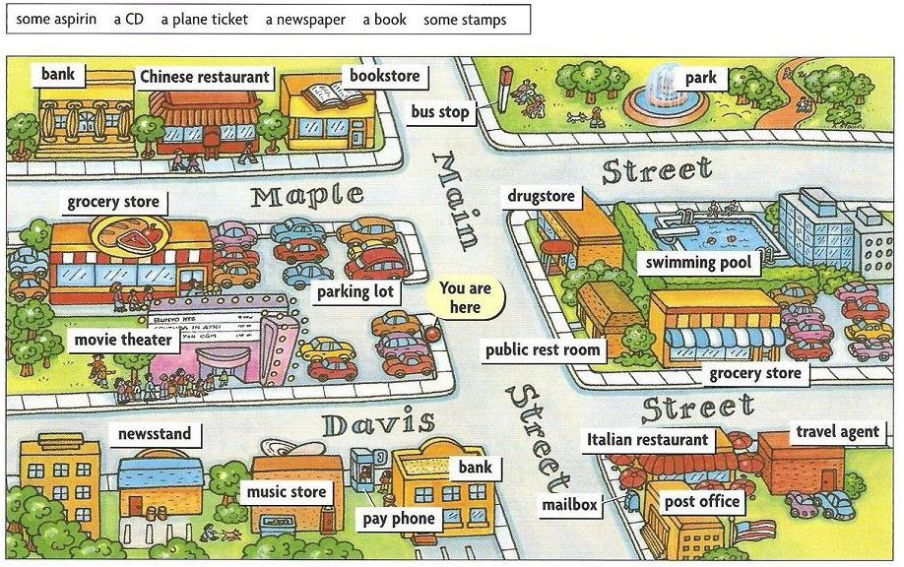
Total 3

Task | Descriptor | Mark | Additional information
 | A learner
1 | Possible answers:  1. My ideal place to live is in a small town in the countryside | 1
 | 2. My ideal neighbourhood has got tree-lined streets and parks, shops, a cinema and a cool café | 1
 | 3. The local people are friendly and don’t mind helping each other out. | 1
2 | 1. supermarket
 | 2. library
 | 3. jewelers
 | 4. florist`s
3 | 1.Cross the Maple street and go straight ahead | 1
 | 2. Cross the Main street, turn left and go straight ahead to the David Street, turn left . It is on t5he corner of Main street and David street. | 1
 | 3.Go to the Main street then cross the Maple street, turn left and go up the Main street. It is opposite the bank and near the Italian restaurant | 1
Total marks |  | 10

