Unit: | Buildings
School: | N2 Kainazar village secondary school
Teacher name: | Kudaibergenova A.D.
Date: | 28,29.12.20
Grade: 3 | Number present: | Number absent:
Theme of the lesson: | Unit revision
Learning objectives(s) that this lesson is contributing to | 3.2.2.1- ask questions to find out about present experiences on a limited range of general and some curricular topics;  3.3.3.1- begin to read with rereading and usual support very short simple fiction and non-fiction texts on a limited range of general and curricular topics;
Lesson objectives | Learners will be able to:  -Provide personal sentences about town;  -Practice describing location of people and position of things using at, behind, between, in, in front of, near, next to, on, under, above
Lesson plan
Planned timings | Teacher's actions | Pupils` actions | Assessment | Resources
10  minutes | ORGANISATION MOMENT:  Teacher greets students | Students respond to greeting and take their places | -
20  minutes | MAIN PART  Presentation and practice  - Listen, point and repeat.  To put up the picture of the house on the board. To say: This is house. In the house there is a room. To poster the picture “My room”. Point the things inside a room (bed, chair, TV, table, desk) one at a time and say the corresponding words. The pupils repeat chorally and individually.  T: bed, chair, TV, table, desk  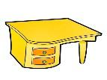  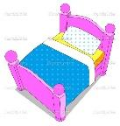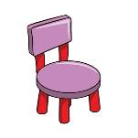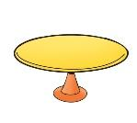  - Game: Magic eyes!  - Colour and say  To point to the pictures and say their colours.  Look! This is bed. It is blue  This is desk. It is red  This is table. It is yellow  This is chair. It is green  This is TV. It is purple  To ask pupils to repeat chorally and individually  - Practice  To give pupils cards and ask to colour the furniture. After colouring the describe their picture  Dynamic pause.  T: Friends, stand up. Let’s relax  Song: Clap your hands | Listen, point and repeat.  give pupils cards and ask to colour the furniture | Formative assessment | Flashcards of things in a room
10  minutes | ENDING THE LESSON:  Well what did we do in our lesson?  - Evaluation of the lesson  Give the home task  Sing a Good bye song | Children sing a Good bye song | Feedback | https://www.youtube. com/watch?v= Xcws7UWWDEs

