Gymnasium of the №17th comprehensive school named after Ivan Trubitsyn
Short term plan
The theme of the lesson: Hot and Cold
Grade:1
Teachers name: Kulusheva T.T

2020-2021academic year

Long term plan module: Unit4:The world around us
The theme of the lesson: Hot and Cold
Date: 14.12.2020
Class: 1Б |  |  |  | Number of present:10 |  | Absent:2
Learning objective(s) that this lesson is contributing to: | 1.L3 recognise with support common names and names of places, recognise the spoken form of a limited range of everyday and classroom words  1.S3 pronounce familiar words and expressions intelligibly  1.S5 use words in short exchanges  1.UE3 use basic adjectives to describe people and things  1.UE7 use personal subject and object pronouns to give basic personal information
Lesson objectives: | All learners will be able to:  Listen and repeat the words according to the topic  Recognize more than 6 in activities
Most learners will be able to:
Recognize more than 7 and name some words according to the topic
Can answer short questions
Some learners will be able to:
Recognize and name most of the words according to the topic “Animals”
Language objectives: | Learners can:  -greet one another using phrases: Hello. I’m ……. What is your name? My name is….;  - pronounce familiar words and expressions intelligibly;  - Name animals, Days of the week
Key words and phrases: hello, I, your, my, name, what
Hello. I’m ……. What is your name? My name is….
 | Useful classroom language for dialogue/writing: oral
 | Discussion points:
 | Can you say why we greet one another?
Previous learning:  Success criteria  Value links  Cross-curricular links  ICT skills | Animals,Days of the week  Learners have met this learning objective if they can:Remember at least 5or 6 words correctly  Lifelong learning  Self study, Art  Using videos,Pictures,PPT,online games
Intercultural awareness | Weather in different countries
Pastoral care  Health and safety  Assessment for Teaching | Assure you met all learners emotional,mental and physical needs  Make sure for everyday mobile precautions  Criteria based assessment. Assessment criteria: Introduce himself/herself clearly.  Descriptor:  A learner  greets himself/herself correctly;  says “hello” clearly  Self-assessment: Hand signals
How to overcome barriers in learning English | -Encourage learners to dialogic learning.  -Use their mother tongue to start.
Lesson Plan
Planned timing |  |  | Planned activities (replace the notes below with your planned activities)  What will the pupils learn? How will they learn it?  Suggested Teaching Activities  Active Learning activities |  |  |  | Resources
Start (Beginning of the lesson)  5min |  |  | Greeting: Teacher teaches the learners to greet one another in English; learners respond to greeting of the teacher. Warming up: Act out the situation in the picture. Use greetings and goodbye words: Hello, hi, good morning, good afternoon, good bye, nice to meet you, see you.  Explain the aims of the lesson:Today we are going to learn the words:Hot and Cold |  |  |  | https://youtu.be/OsFV5 8Jps2k
Middle (of the lesson)  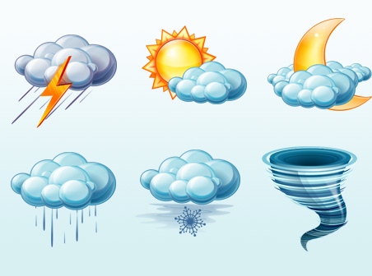  20min |  |  | D) Teacher demonstrates and drills different weather adjectives using flashcards,videos  Learners watch a video about greeting carefully and follow the instructions to make circles and practice the words in English.  Listening  Listen a song “its rainy”Teacher demonstrates images and different weather adjectives:hot,cold,rainy,wet,cloudy,sunny,windy, snowy.  Singing  Singing along to the song and then practising showing weather visuals.  Sing along to song animation two or three times and then see if learners can sing song with just the music.  Assessment  Pupils draw the weather according to Teachers instructions.Give instructions such as:Three:Its cloudy….  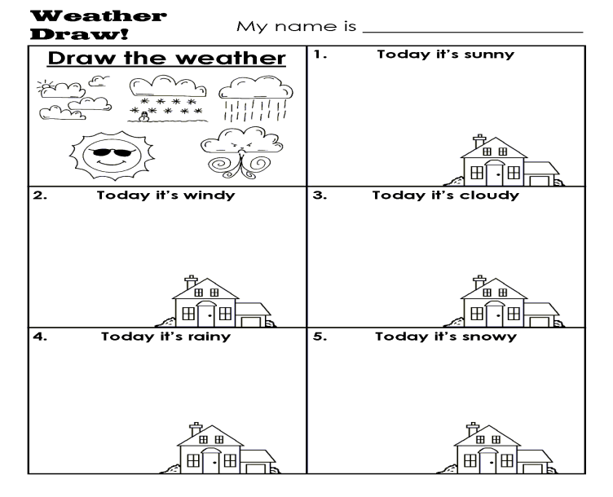 |  |  |  | Its rainy song,  http://www.youtube.com/watch?v=SA z Wo5LGF0  Worksheet “Weather Draw”  https://www.google.ru/search?
End (of the lesson)  5min |  |  | Reflection Self-assessment: Hand signals  Ask students to look at lesson objectives they set at the beginning of the lesson and think and say what they did well in the lesson and what needs improvement.  Feedback |  |  |  | Weather song for kids:The Sun Comes Up!  http://www.youtube.com/watch?v=XcW9Ct000yY
Additional information:
Differentiation - how do you plan to give more support? How do you plan to challenge the more able learners? |  | Assessment - how are you planning to check learners’ learning? |  |  | Cross – curricular links health and safety check ICT links  Values links
Reflection  Were the lesson objectives / learning objectives realistic?  What did the learners learn today?  What was the learning atmosphere like?  Did my planned differentiation work well?  Did I stick to timings? What changes did I make from my plan and why? |  | Use the space below to reflect on your lesson. Answer the most relevant questions from the books on the left about your lesson.
Summary evaluation 1.What two things went really well (consider both teaching and learning)?
2. What two things would have improved the lessons (consider both teachings and learning)?
What have learned from his lesson about this lesson about the class or individuals that will inform my next lesson?

