Unit: | LESSON: Unit 2: My family and friends.
Teacher name: | Amirova A
Date:
Grade: 2 | Number present: | Number absent:
Theme of the lesson: | My family and friends
Learning objectives(s) that this lesson is contributing to | - 2.L3 understand the main points of short, slow and carefully articulated talk on routine and familiar topics features such as colour and number 2.R1 read and spell out words for others 2.W2 write letters and familiar high frequency words when read aloud or spelt
Lesson objectives | Learners will be able to:  - Identify and respond the teacher`s questions using can and can`t with limited support  use the modal verbs can/can`t when the learners speak about their abilities, using the new words, for example: I can run, a can`t sing

Lesson plan
Planned timings | Teacher's actions | Pupils` actions | Assessment | Resources
10  minutes | ORGANISATION MOMENT:  -Good morning! -Nice to meet you again! -How are you? -We are fine! Шаттық шеңбер: «I wish» Children come here and make a circle. Today I wish good luck, success I will divide into groups with candies. Sit down, please.  Warm up Look at the picture. What do you see in this picture? | Students respond to greeting and take their places | - | interactive board
20  minutes | MAIN PART  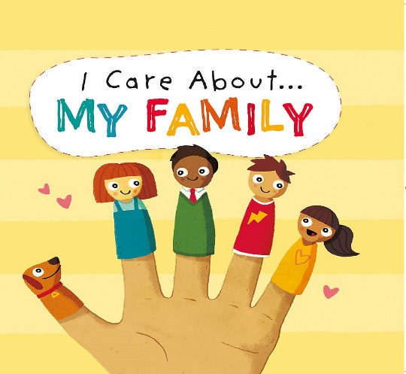  Now pupils look at the pictures and Today, we repeat dictionaries Listen to me please and repeat them after me. The teacher introduces words to pupils. New words mother mummy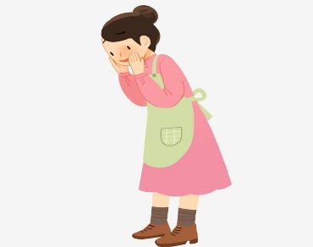  father daddy 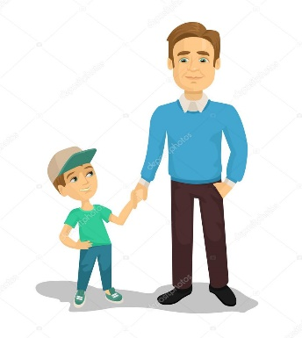grandmother grandma Glossary  grandfather grandpa sister brother  Family Family-a group of people who are related to each other, such as a mother, a father, and their children: Ex 3 p14 Read , look and write the names. Make a poster. Give assessment with traffic light And now pupils, are you tired? Stand up, let’s do exercises  Ex 4 p15 Complete. Find the Stickers at the back of the book. | Pupils answer teacher`s questions | Formative assessment | interactive board  video from YouTube  Activity Book
10  minutes | ENDING THE LESSON:  Ex 10 p23 Answer the email about yourself ,include in picture. The teacher asks pupils what have they learnt from the lesson, if they have known any new words. Also the teacher comments the work of every child. What did you learn today? What was difficult for you today? Who was the best pupil today? Home work: Revision | Learners orally answer the questions | Feedback | -

