Unit: Healthy world |  | School: Ulykbek
Date: |  | Teacher name: Khasanova U.
CLASS: 4 |  | Number present: |  | absent:
Lesson title |  | Healthy bodies
Learning objectives |  | 4.S5 pronounce an increasing range of words and short phrases and simple sentences intelligibly  4.W7 spell most familiar high-frequency words accurately when writing independently  4.R1 read and spell out words for others
Lesson objectives |  | All learners will be able to:  ✓ pronounce words and use words in short exchanges, to talk about ability with some support  Most learners will be able to:  ✓ pronounce words and use words in short exchanges, to talk about ability with some support  ✓ read words and expressions, spell words correctly and use them in both oral and written speech  Some learners will be able to:  ✓ pronounce words and use words in short exchanges, to talk about ability with some support  ✓ read words and expressions, spell words correctly and use them in both oral and written speech
Assessment criteria |  | Revise the previous vocabulary with the help of the method “Walnut”.  Write at the table healthy or unhealthy names of foods  Make up short sentences.
Level of thinking  skills |  | Knowledge, Understanding, Application
Values links |  | Language
Cross-curricular links |  | Uzbekh, Russian, Biology
Previous learning |  | Learners have previor knowledge of some of the vocabulary related to the topic “Healthy bodies”
Plan
Planned timings | Planned activities (replace the notes below with your planned activities) |  |  |  | Resources
Start  2 min  5 min | - Organization moment  One, two, three, four,  Mmm… young me chocolate giving more  Five, six, seven, eight  Very tasty my chocolate.  II. Check up their homework  Method “Walnut”  In the walnut have words. Open the walnut, read the words and translate  Marking: “Well done”, “Very good”, “Very well”  Divide into two groups by using <<ice cream spoons>>.:  I – group “ice cream”  II – group “pizza” |  |  |  | Ice cream spoons
Middle  7  min  5  min  2  min  5  min  8 min  5 min | III. The presentation of the new lesson  Work with new words  Salt [sɔːlt] туз  Pepper [ ˈpepə(r) ] мурч  Cabbage [ˈkæb.ɪdʒ] карам  Pizza [ˈpiːt.sə] пицца  Sausage [ˈsɒs.ɪdʒ] колбаса  Olive oil [ˈɒl.ɪv ɔɪl] усимлик ёғи  Mayonnaise [ ˈmeɪ.ə.neɪz] майонез  Lettuce [ ˈlet.ɪs] салат  Cucumber [ˈkjuː.kʌm.bər]бодринг  Mushroom [ˈmʌʃ.ruːm] қузиқорин  Teacher will read new vocabulary.  Task 1. Writing. In pairs, write in the table names of the foods healthy or unhealthy:  sausages, apple, fries, tomato, cucumber, yogurt,  banana, pizza, cabbage, grape.  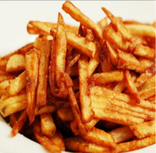  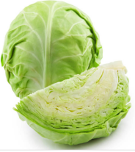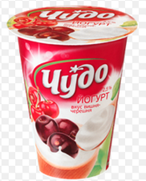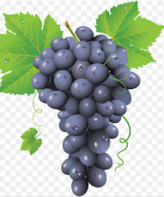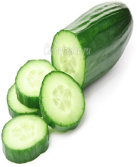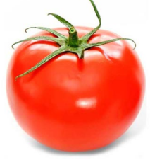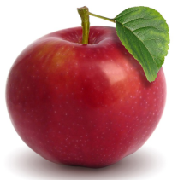  Healthy Unhealthy  Assessment criteria: learners are asked to compare the results of their task.  Descriptor: A learner can:  ✓ follow teacher’s instruction  ✓ work in group.  Marking: “Stars”  V. Relaxation moment. “Video”  Task 2. Speaking. Learners will make a salad. In group, decide what to include.  Descriptor: A learner can:  ✓ work in group;.  ✓ make up short sentences.  Marking: “Stickers”  Differentiation  Task1  Task2  Game : “My thinking cap”  Answer the questions  Teacher:  - What do you always eat?  - What do you sometimes eat?  Learner:  I always eat……  I sometimes eat…... |  |  |  | PPT  pictures  table  Video  Fruits and vegetables
End  2  min | Feedback: method “Insert”.  Homework: learn by heart new words |  |  |  | pictures
Additional information
Differentiation – how  do you plan to give more support? How do you plan to challenge the more able  learners? |  |  | Assessment – how are  you planning to check learners’ learning? | Health and safety  check
Reflection  Were the lesson objectives/learning objectives realistic?  What did the learners learn today?  What was the learning atmosphere like?  Did my planned differentiation work well?  Did I stick to timings? What changes did I make from my plan and why? | Use the space below to reflect on your lesson. Answer the most relevant questions from the box on the left about your lesson.

