Short term plan

Unit of a long term plan: Our countryside |  |  |  |  | School:
Date: |  |  |  |  | Teacher name: Alipaeva Aigul
CLASS: 6 |  |  |  |  | Number present: |  |  | absent:
Lesson title |  |  | National parks in Kazakhstan
Learning objectives(s) that this lesson is contributing to (link to the Subject programme) |  |  | 6.4.2.1-understand independently specific information and detail in short ,simple texts on a limited range of general and curricular topics;  6.5.1.1 plan, write,edit and proofread work at text level with some support on a growing range of general and curricular topics;
Lesson objectives |  |  | All learners will be able to:  - Can read correctly and write name of the parks  Most learners will be able to:  - answer the questions according to the given text  Some learners will be able to:  -make up sentences using the new words
Assessment criteria |  |  | Use talk or writing as a means of reflecting on and exploring a range of perspectives on the world  Plan, write, edit and proofread work at text level with some support
Level of thinking |  |  | Understanding, Application, Evaluation
Values links |  |  | National unity and peace and harmony in our society learners to love their home and protect natural parks
Cross-curricular links |  |  | Biology, Geography
Previous learning |  |  | Description of wildlife
Plan
Planned timings | Planned activities (replace the notes below with your planned activities) |  |  |  |  |  | Resources
Start  3 min  5 min  2 min | Greeting: Teacher greets the learners, the learners respond to greeting and take their places  - Good morning pupils!  - Sit down!  - Who is on duty today?  - Who is absent?  - What date is it today?  - What is the weather like today?  Teacher introduces with the lesson objectives  Dear pupils! Today we are going to talk about Natural Parks!  -To show the video about National parks;  -What kind of parks do you know?  -What are the names of the National parks?  -Where are they situated?  -What are some of the unusual animals and plants in the parks?  - Please, tell me about them?  AFL:oral assessment  Dividing the class into subgroups with the pictures of parks :Altyn –Emel and Burabay.“Puzzle”activity. Each learner will take a picture about parks, so the class will be divided into 2 groups. |  |  |  |  |  | Pictures of parks Altyn-Emel and Burabay
Middle  7 min  5 min  7 min  8 min  3 min | (I)Task 1.Pre-reading task: Work as a whole class  Working with the text  -Read the text attentively and translate:  -Texts about National parks Altyn-Emel and Burabay:  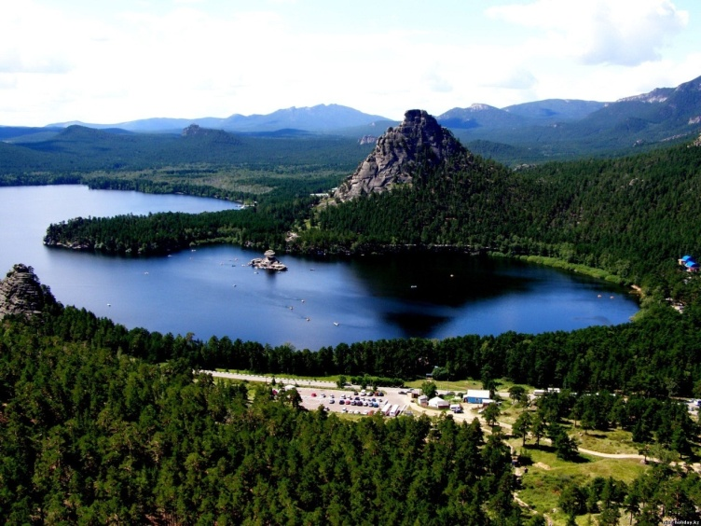  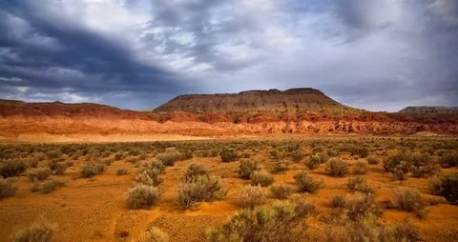  Altyn-Emel National park  The Altyn-Emel National park is very big :it covers 4,600 km in south –east Kazakhstan .It lies between the River Ili and the Aktau Mountains.This is avery dry part of the country where life is hard.But in this difficult environment there are around 1,800species of plants, including willows and honeysuckles;32 types of fish,and around 260 species of vertebrates. There you can see four types of eagle including Imperial and Golden eagles,as well as eagle owls. Other attractions of the park are the singing sand dunes and the Aktau Mountains.  Burabay National park  In the north of Akmola region ,the «Burabay» is located . This resort pearl of Kazakhstan is a fantastic mountainous land harboring mysterious wonders.The «Burabay» was established in August 2000. The park is under the direct jurisdiction of the President of Kazakhstan .Borovoye Lake is situated at the height of 319 meters above the sea level.Borovoye is beautiful in any season.The woodland of Borovoye is full life :the number of wild animals species is over 300,the vegetable kingdom represents great plant diversity.  - Identify the sentence true or false  Altyn-Emel  1 The Altyn-Emel National Park is very big T  2 It lies between the River Ili on the Alatau Mountains. F  3 This is a very wet part of the country where life is hard F  4There are around 2000 species of plants ,including willows and honeysuckles F  Burabay Park  1 The Burabay National park is a natural park located in Aqmola Region.T  2 This is a resort of Kazakhstan is a fantastic mountainous land. T  3 The Burabay was established in June 2001. F  4 There is a mountain named by Jumbaktas. F  Descriptor: 1. Reads the text correctly.  2. Identifies the sentences true or false  Task 2.Individual work.  - You must using these words and make-up short story about National parks Altyn-Emel and Burabay  Working with the key words from the text  Key words: Environment-қоршаған орта  -Located-орналасу  -National park-ұлттық парк  - Species-түрі  -Animals-жануарлар  -Plants-өсімдіктер  -Vertebrates-омыртқалы жануарлар  -Wildlife-тірі,жабайы табиғат  -Types-түрі  - Eagles-қырандар,бүркіттер  -Towards-тікелей  -Establishment-жариялану  -Temperature-температура  -Beautiful-әдемі  -Height-биіктігі  -Situated-орналасқан  -Vegetable-көкөніс  Descriptor:  1.Makes up sentences using these  new words with support.  2.Writes a short story about parks  Task 3 Pair work  - You must put the missing words from the text(National park,between,around,Akmola,August,is)  Differentiation by support: Teacher gives the 5 sentences to less able students.  -1The Altyn-Emel is ------South-east Kazakhstan.  -2It lies --------the River Ili and the Aktau--------  -3There are paintings on------------of the rocks.  -4But in this difficult environment there are --------1,800species of plants.  -5In the north of ----------region,the Burabay is located.  Differentiation by ability: Teacher gives the 7  sentences for more able students.  -1The Altyn-Emel is ------South-east Kazakhstan.  -2It lies --------the River Ili and the Aktau--------  -3There are paintings on------------of the rocks.  -4But in this difficult environment there are --------1,800species of plants.  -5In the north of ----------region,the Burabay is located.  -6 The Burabay was established in -----------2000  -7 The Burabay ------ beautiful in any season.  Descriptor:  1.Understands the sentences:  2. Puts the missing words:  Rest time:  Teacher: Stand up, please.  Stand up and look around  Shake your head and turn around  Stamp your feet upon the ground  Clap your hands and then sit down.  Feedback:  A Tree of success  Green leaf - I totally understand  Yellow leaf - I understand the lesson but I need some helps  Red leaf - I don't understand  Home task:  For less able learners: make up sentences about National Parks using new words:  For more able learners: write an essay about National Parks |  |  |  |  |  | Pictures of parks Altyn-Emel and Burabay  Formative assessment  New words
Additional information
Differentiation – how do you plan to give more support? How do you plan to challenge the more able learners? |  |  |  | Assessment – how are you planning to check learners’ learning? |  | Health and safety check
Task 1 Pre-reading task:Work as a whole class.Working with the text. Identify the sentences true or false.  Task 2 Individual work.  Students must make up short story about Parks using new words from the text.  Task3.Differentiation by support: Teacher gives the 5 sentences to less able students about “National park”  Differentiation by ability: Teacher gives the 7 sentences for more able students. About National park. |  |  |  | “Think Together” activity |  | Health saving technologies.  Using physical exercises and active activities.  Rules from the Safety Rules book which can be applied in this lesson.
Reflection  Were the lesson objectives/learning objectives realistic? Did all the learners achieve thel esson objectives/ learning objectives? If not, why?  Did my planned differentiation work well?  Did I stick to timings?  What changes did I make from my plan and why? |  | Use the space below to reflect on your lesson. Answer the most relevant questions from the box on the left about your lesson.
Summary evaluation

What two things went really well (consider both teaching and learning)?

1:

2:

What two things would have improved the lesson (consider both teaching and learning)?

1:

2:

What have I learned from this lesson about the class orindividuals that will inform my next lesson?

