Short term lesson plan

Unit of a long term plan:  Unit 3 Our Countryside. Lesson plan 27 |  |  |  | School:
Date: |  |  |  | Teacher's name:
CLASS: 6 |  |  |  | Number present: |  | absent:
Lesson title |  | Language Focus. Present Continuous
Learning objective(s) |  | 6.C6 organise and present information clearly to others ( Ex.1 p.35)  6.W2 write with minimal support about real and imaginary present events, activities and experiences happening now on a range of familiar general topics and some curricular topics ( Ex.2,3,5 p.35)  6.L6 deduce meaning from context in short, supported talk on an increasing range of general and curricular topics( Ex.4 p.35, describe a picture)  6.S2 ask simple questions to get information about a limited range of general topics ( Ex.6)
Lesson objectives |  | All learners will be able to:  - Identify the theme, new grammar material, active vocabulary and use them as the basis for discussion.  - Transfer information from the reading passage about a rule into a graphic organizer.  - Offer constructive peer-feedback using rubric.  Most learners will be able to:  - Select, compile, and synthesize information for an oral presentation.  Some learners will be able to:  - Respond to and discuss the topic using interpretive, evaluative and creative thinking skills and right forms of the Present Continuous Tense describing pictures.
Level of thinking |  | Higher order thinking skills (according to the revised Bloom's taxonomy).
Assessment criteria |  | - Read the given sentences and identify the general information.  - Demonstrate skills of organizing and expressing ideas accurately.  - Illustrate a viewpoint in a discussion.
Target language |  | To happen, change, the main verb, verb ending, vowel/ consonant.
Values links |  | Responsibility, Global Citizenship
Cross-curricular links |  | Kazakh language, Social Science, Natural Science
Previous learning |  | Vocabulary related to animals
Plan
Planned timings | Planned activities (replace the notes below with your planned activities) |  |  |  |  |  | Resources
Start  5 min | The lesson greeting.  Warm-up  - Teacher suggests singing a fun song for the start of the lesson.(" Animal song")  - Learners are informed about the lesson objectives  Teacher informs that they are going to meet basic rules for the grammar tense. |  |  |  |  |  | Slide (objectives)  http://apple.co/1ipOxXl  Slide (useful phrases)
Main part | The main part of the lesson  The teacher asks Sts. what they do every day. Do you do a homework every day? Then asks one of them to stand up. What is he doing now? He is standing up.  What is she / he doing now? She is...  They are......  What can you say about Present Continuous Tense?  In groups think of a mind - map and explain the rule of this grammar tense.  The present continuous tense is formed from the present tense of the verb be and the present participle  (-ing form) of a verb:  Use  1. We use the present continuous tense to talk about the present: for something that is happening at the moment of speaking ( now):  Please be quiet. The children are sleeping.  Ex. 1 - 2 p.35  Listening Comprehension Exercise 3 p.35.  Be attentive with the pronunciation of the ending - ing.  Check your answers and put your score for this exercise.  1. Two dogs are running in the park.  2.A parrot is speaking English.  3.A man is attacking a mosquito.  4.A whale is singing to its partner.  5.Children are making a cake.  6.A girl is practising the piano.  7.A lion having a meal.  Work in pairs. Make affirmative and negative sentences in the Present Continuous: Ex.4, 5 p.35.  3 minutes physical activities  http://pedtehno.ru/content/fizkultmin...  While describing a picture, we use Present Continuous Tense. Take any picture and say what people are doing there.  Write on lists of papers the activity of your classmates, give it to another person who has to guess who is that person. E.g. He is not writing, he is talking. Is it Ann?  Ex.6. |  |  |  |  |  | Whiteboard  https://www.youtube.com/watch?v=8Q2sGr1ZsJg  Pictures  Writing  Worksheets  St. Book p.35  CD 1.30  Writing  Worksheets  PPT  Pictures  Student's Book p.35
End | Home task. WB p.25  Think about describing a picture.  Students express their attitude to the lesson and give self-assessment using the method: “Six thinking hats”:  - Green: How can you use today's learning in different subjects?  - Red: How do you feel about your work today?  - White: What have you leant today?  - Black: What were the weaknesses of your work?  - Blue: How much progress have you made in this lesson? (Now I can, I still need to work on, I've improved in, Today I learnt... )  - Yellow: What did you like about today's lesson? |  |  |  |  |  | Slide (Homework)  Slide "Six thinking hats"  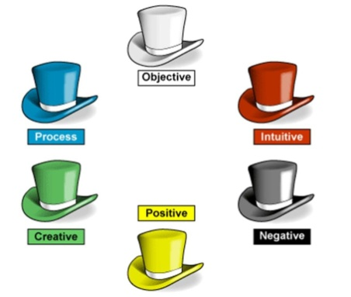
Additional information
Differentiation – how do you plan to give more support? How do you plan to challenge the more able learners? |  |  | Assessment – how are you planning to check learners’ learning? |  | Health and safety check
Differentiation can be achieved through content (Based on the theory of Multiple Intelligences different tasks are used with the same text).  By support:  Less able learners will be supported through step-be-step instructions, glossaries, thinking time.  By task:  For more able learners additional leveled tasks are offered. |  |  | Assessment criteria:  - Read the given passage and identify the general information.  - Demonstrate skills of organizing and expressing ideas accurately.  - Illustrate a viewpoint in a discussion.  Descriptors:  A learner  - reads the text for global understanding;  - selects meaningful information, constructs the answer;  - presents information in the group discussion.  - evaluates the peers’ answers.  Teacher's observation using observation checklist.  Self-assessment. |  | Health saving technologies.

Appendix2
Teacher observation checklist

Student's name ________________________________________

Positive Aspects
- Completed the individual role-card.
- Used extracts from the text to support his/her ideas.
- Asked open-ended questions.
- Listened while others talked.
- Encouraged peers to share their ideas.
- Added his/her own comments and ideas to other student's comments and ideas.
Negative Aspects
- Didn't complete the individual role-card.
- Didn't appear to be listening or interrupted when others were speaking.
- Did not use text to support his/her opinions.
Comments ___________________________________________________

Student Self-Assessment Checklist Student
Name: ________________________
Date: ______________________ Think about how well you are working in your group.
Place a check mark beside the skills you demonstrate in your role.
I listen attentively to others.
I express my thinking clearly and concisely.
I take turns. I encourage participation of all group members.
I show respect for alternative points of view.
I disagree agreeably.
I synthesize information from others.
I analyze ideas of others.
I remember significant information.
I identify issues.
I make connections to prior knowledge and experiences.

Short term lesson plan

Unit of a long term plan:  Unit 3 Our Countryside. Lesson plan 28 |  |  |  | School:
Date: |  |  |  | Teacher's name:
CLASS: 6 |  |  |  | Number present: |  | absent:
Lesson title |  | Animal behaviour
Learning objectives(s) |  | 6.C1 use speaking and listening skills to solve problems creatively and cooperatively in groups ( Ex.1,2 p.36)  6.S7 use appropriate subject-specific vocabulary and syntax to talk about a range of general topics, and some curricular topics ( Ex.3 p.36)  6.L2 understand with little or no support most specific information in extended talk on a wide range of general and curricular topics( Ex.4 p.36)  6.W3 write with support factual descriptions at text level which describe animals ( Ex.5,6 p.36).
Lesson objectives |  | All learners will be able to:  - Identify the theme, new words, understand an interview about animal's behaviour use them as the basis for discussion with a correct grammar tense.  - Transfer the given information into a graphic organizer.  - Offer constructive peer-feedback using rubric.  Most learners will be able to:  - Select, compile, and synthesize information for an oral presentation.  - Demonstrate the ability to write grammatically correct sentences on familiar topics;  Some learners will be able to:  - Respond to and discuss the texts using interpretive, evaluative and creative thinking skills.  - Demonstrate the ability to ask a variety of questions in different tenses;
Level of thinking |  | Higher order thinking skills (according to the revised Bloom's taxonomy).
Assessment criteria |  | - Read the given passage and identify the general information.  - Demonstrate skills of organizing and expressing ideas accurately.  - Illustrate a viewpoint in a discussion.
Target language |  | Beaver, dam, salmon ,chase, enormous, hole, move.
Values links |  | Appreciating the love to animals
Cross-curricular links |  | Natural Science, Social Science, History, Geography
Previous learning |  | Vocabulary related to people's active way of life
Plan
Planned timings | Planned activities (replace the notes below with your planned activities) |  |  |  |  |  | Resources
Start  5 min | The lesson greeting.  The teacher sets the lesson objectives, letting students know what to anticipate from the lesson.  Warm up.  Then to create a positive learning environment the teachers asks students to start the lesson giving each other compliments about appearance, job performance, talent, etc. and also practice accepting compliments.  (E.g. - Hello, my friend, you look beautiful today!  -That's very nice of you to say so.)  Pre-learning  Hot Seat Game  - One learner sits in front of the class. Teacher hands a strip of a paper with the name of an activity from the previous lesson. The classmates should guess the word by asking some questions:  Are the boys feeding animals?  Is the girl feeding ducks?  Are people hunting?  Is a falcon flying in the park?  Teacher elicits the knowledge of making question rule and helps learners to remember the rules for making affirmative and negative sentences with Present Continuous. |  |  |  |  |  | Slide (objectives)  Slide (useful phrases)  Writing  Worksheets
Main part | The main part of the lesson.  The consolidation of the theme about animals. Group Work of 4.  Mammals Reptiles Insects Birds  Each group will give a short information about their animals.  Reptiles are animals without wings who lay eggs. Some reptiles are very dangerous.  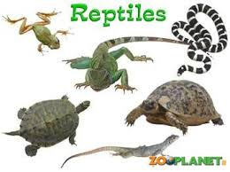  Give characteristic of the following. Make as many sentences as you can.  Begin your sentences “I think…”.  I think that a monkey is funny.  a tiger tortoise  a crocodile a rabbit  birds snakes  a fox a bear  a giraffe  Today we'll speak about animals behaviour.  BEHAVIOUR  With what words can you associate it:  conduct, action, activity, doings, manners.  So, what can animals do? Write as many activities as you know?  What is it doing?  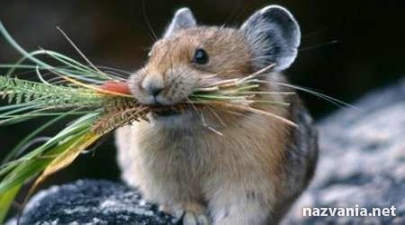  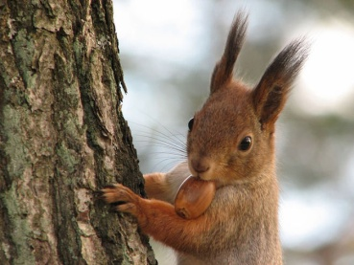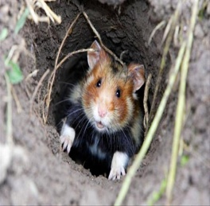  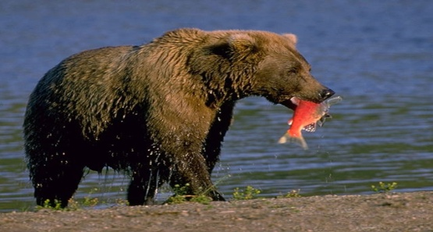  Ex. 1 - 2 p.36(activity of animals)  What six animals can you see on page 36? Why do we use Present Simple in this exercise?  Listen to the interview with Mike and try to understand which of the photos he speaks about? While listening, do also Ex.4.  He speaks about pictures: 1,3,4,6.  Speak about any animal you know, use plan of Ex.5:  I'm going to speak about.......  I want to present this animal to you....  Let me introduce this amazing animal or bird to your attention..... |  |  |  |  |  | Whiteboard  A table  A presentation  " Wild animals".  Writing  Worksheets  Writing  Worksheets  Pictures  CD 1.31  Student's Book p.36
End | Home task. WB p.26  Think about activities of the animal.  Students express their attitude to the lesson and give self-assessment using the method: “Six thinking hats”:  - Green: How can you use today's learning in different subjects?  - Red: How do you feel about your work today?  - White: What have you leant today?  - Black: What were the weaknesses of your work?  - Blue: How much progress have you made in this lesson? (Now I can, I still need to work on, I've improved in, Today I learnt... )  - Yellow: What did you like about today's lesson? |  |  |  |  |  | Slide (Homework)  Slide "Six thinking hats"
Additional information
Differentiation – how do you plan to give more support? How do you plan to challenge the more able learners? |  |  | Assessment – how are you planning to check learners’ learning? |  | Health and safety check
Differentiation can be achieved through content (Based on the theory of Multiple Intelligences different tasks are used with the same text).  By support:  Less able learners will be supported through step-be-step instructions, glossaries, thinking time.  By task:  For more able learners additional leveled tasks are offered. |  |  | Assessment criteria:  - Read the given passage and identify the general information.  - Demonstrate skills of organizing and expressing ideas accurately.  - Illustrate a viewpoint in a discussion.  Descriptors:  A learner  - reads the text for global understanding;  - selects meaningful information, constructs the answer;  - presents information in the group discussion.  - evaluates the peers’ answers.  Teacher's observation using observation checklist (Appendix 2 - reference to the resource "Literature Circle Role Sheets" by Christine Boardman Moen. p.28) and monitoring.  Self-assessment. |  | Health saving technologies.

Appendix2
Teacher observation checklist

Student's name ________________________________________

Positive Aspects
- Completed the individual role-card.
- Used extracts from the text to support his/her ideas.
- Asked open-ended questions.
- Listened while others talked.
- Encouraged peers to share their ideas.
- Added his/her own comments and ideas to other student's comments and ideas.
Negative Aspects
- Didn't complete the individual role-card.
- Didn't appear to be listening or interrupted when others were speaking.
- Did not use text to support his/her opinions.
Comments ___________________________________________________

Student Self-Assessment Checklist Student
Name: ________________________
Date: ______________________ Think about how well you are working in your group.
Place a check mark beside the skills you demonstrate in your role.
I listen attentively to others.
I express my thinking clearly and concisely.
I take turns. I encourage participation of all group members.
I show respect for alternative points of view.
I disagree agreeably.
I synthesize information from others.
I analyze ideas of others.
I remember significant information.
I identify issues.
I make connections to prior knowledge and experiences.

