Short term lesson plan

Unit of a long term plan:  Unit 4 Drama and comedy. Lesson plan 40 |  |  |  | School: Beineu CSS
Date: 19/12/2019 year |  |  |  | Teacher's name: Shonaeva Dina
CLASS: 6 A |  |  |  | Number present: |  | absent:
Lesson title |  | Describing People
Learning objectives(s) |  | 6.S7 use appropriate subject-specific vocabulary and syntax to talk about a range of general topics, and some curricular topics  6.L2 understand with little or no support most specific information in extended talk on a wide range of general and curricular topics  6.R2 understand with little support specific information and detail in short, simple texts on a limited range of general and curricular topics
Lesson objectives |  | All learners will be able to:  - Identify the theme, new words and use them as the basis for discussion.  - Demonstrate basic knowledge for usage of the Past Simple and Present Simple.  - Transfer information from the given information into a graphic organizer describing people.  - Offer constructive peer-feedback using rubric.  Most learners will be able to:  - Select, compile, and synthesize information for an oral presentation  - Provide a point of view in conversations and discussions;  Some learners will be able to:  - Respond to and discuss the reading passage using interpretive, evaluative and creative thinking skills.  - Make a presentation about a person you love and respect.
Level of thinking |  | Higher order thinking skills (according to the revised Bloom's taxonomy).
Assessment criteria |  | - Read the given text and identify the general information.  - Demonstrate skills of organizing and expressing ideas accurately.  - Illustrate a viewpoint in a discussion.
Target language |  | Appearance, moustache, curly, slim, average, height, fat, blond, fair, straight, beard, poison, glasses, purple hair.
Values links |  | Responsibility, Global Citizenship, respect, love to people around you.
Cross-curricular links |  | Social Science, love and care about people.
Previous learning |  | Past Simple: Regular and Irregular verbs
Plan
Planned timings | Planned activities (replace the notes below with your planned activities) |  |  |  |  |  | Resources
Start  5 min | Pre-learning (W)  - Greeting .Talk with duties  - Dividing into two groups with words  1group – verbs. 2 group – adjectives.  Then learners must do about regular and irregular verbs  Regular verbs Irregular verbs  Played did  Acted won  Designed gave  Brainstorming. 1.``Picture of a boy and girl``  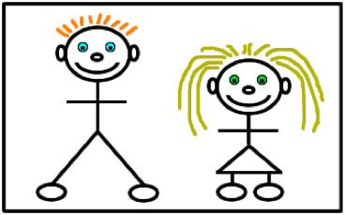  2. ``Picture colours``  r n b I d o l  e s c g p  (Describing people)  Activity 1. `` Gallery pictures``. New words about describing. Start by asking simple questions like ``Look at the gallery pictures? What can you see? `` The first gallery is height. There are 5 words: tall, quite tall, average height, quite short, short  Finish by showing learners word cards. Learners look and read aloud. Do the same for the others  Build:  Hair:  Eye:  Other features: |  |  |  |  |  | Slide (useful phrases)  Pictures  PPT  Whiteboard
Main part | The main part of the lesson.  Activity 2. ``Pictures`` game.  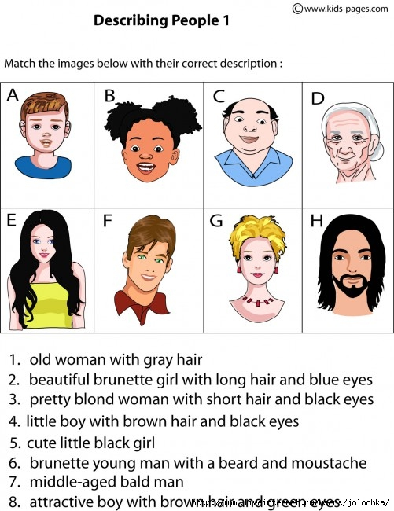  Activity 3. ``Imaginations pictures`` Reading and listening exercise. Ex.3 p.48  A waitress is giving the description of peoples. Listen to the CD very carefully. Fill in a table in groups of 3:  1 person 2 person 3 person  HE/SHE HE/SHE HE/SHE  ………. height ………..build blond ……… Had a ……….. Strange ……… Quite ……… Was……… Purple …….  Activity 4. `` Famous pictures``  Give learners famous people photos. They must write about these people.  - Dimash Kudaibergen  - Dariga Badykova |  |  |  |  |  | Whiteboard  Writing  Worksheet  A table  Student Book p.48
End  3min | Home task. WB p.34  Plenary  Learners fill in the following reflective card in the copy books:  3- new words from the lesson  2- adjectives describing the lesson  1-activity from the lesson you like best
Additional information
Differentiation – how do you plan to give more support? How do you plan to challenge the more able learners? |  |  | Assessment – how are you planning to check learners’ learning? |  | Health and safety check
Differentiation can be achieved through content (Based on the theory of Multiple Intelligences different tasks are used with the same text).  By support:  Less able learners will be supported through step-be-step instructions, glossaries, thinking time.  By task:  For more able learners additional leveled tasks are offered. |  |  | Assessment criteria:  - Read the given passage and identify the general information.  - Demonstrate skills of organizing and expressing ideas accurately.  - Illustrate a viewpoint in a discussion.  Descriptors:  A learner  - reads the text for global understanding;  - selects meaningful information, constructs the answer;  - presents information in the group discussion.  - evaluates the peers’ answers.  Teacher's observation using observation checklist (Appendix 2 - reference to the resource "Literature Circle Role Sheets" by Christine Boardman Moen. p.28) and monitoring.  Self-assessment. |  | Health saving technologies.

Appendix1
Teacher observation checklist

Student's name ________________________________________

Positive Aspects
- Completed the individual role-card.
- Used extracts from the text to support his/her ideas.
- Asked open-ended questions.
- Listened while others talked.
- Encouraged peers to share their ideas.
- Added his/her own comments and ideas to other student's comments and ideas.
Negative Aspects
- Didn't complete the individual role-card.
- Didn't appear to be listening or interrupted when others were speaking.
- Did not use text to support his/her opinions.
Comments ___________________________________________________

Student Self-Assessment Checklist Student
Name: ________________________
Date: ______________________ Think about how well you are working in your group.
Place a check mark beside the skills you demonstrate in your role.
I listen attentively to others.
I express my thinking clearly and concisely.
I take turns. I encourage participation of all group members.
I show respect for alternative points of view.
I disagree agreeably.
I synthesize information from others.
I analyze ideas of others.
I remember significant information.
I identify issues.
I make connections to prior knowledge and experiences.

Beineu CSS

Theme: Describing people

Prepared: Shonaeva Dina

2019-2020 year

