Date: 10.11.2016 Grade: 5 V
The theme of the lesson: My house. My flat.
The aims of the lesson:
- Educational: Presentation of the lesson about My house, my flat, to train new words and discussion an English language

- Developing: To develop the pupils habits of the oral speech , to develop pupils creative and logical abilities, understanding, reading and writing, grammar and lexical skills.

- Bringing-up: to bring up love and interest to the subject, to respect each other, to create an English atmosphere in the classroom.

Inter-subject connection: Kazakh, English
The type of the lesson: presentation, integrative, describing.
Methods of teaching: training, explanation, demonstration, interaction
The equipment of the lesson: diagrams on the tasks, pictures, posters, computers, interactive board.
The procedure of the lesson
- Organization moment
- Greetings
-Good morning children?
-How are you?
- A talk about on duty
-Who is on duty today?
-Who is absent today?
c) A talk about the weather?
-What day is it today? -What season is it now?
-What date is it today? - What month is it now?
3) Warm – up
All of you stand up and come to the blackboard. Look at the interactive board and watch the video then do after them. Ok thank you.
Now who says me What is your H|T?
Brainstorm: I ask you by throwing the ball
1. Tall- short Fair-dark Lazy- hard-working Shy-sociable Fat-slim Big- small
2. What is your name?
3. how old are you?
4. spell the word H A M S T E R, D A R K, B R O W N
5. АПА АТА АНА ӘКЕ АҒА ӘПКЕ
Thank you. Now we use Mosaic method and take this puzzles and collect them. We see rooms. And this room is your group. Now tell me please what room is it?

- The Presentation of the new theme
My house. My flat.
  - Recognition of the meaning
Look at the interactive board and read.

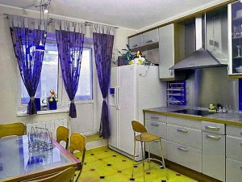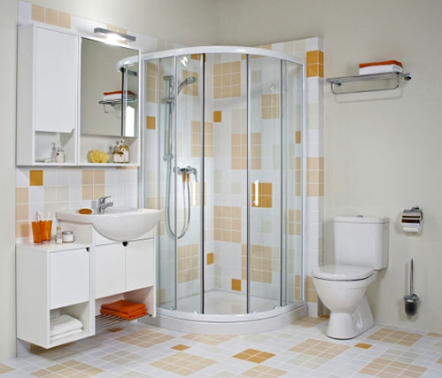

- To learn children new words
  - To work with book

Exercise 1. Look at this plan. Match the words to the numbers.
Exercise 4. Look at the picture. Write the names of the rooms.
- a living room
- a dining room
- a kitchen, a hall
- a bedroom
- a study

Exercise 6. Listen and repeat.
A sofa sofas
An armchair armchairs
A living room
A window
A clock
A book
A table
A carpet
A plant
A door
A chair
A lamp

  - Allegation our theme
- We cook in the …..
- We sleep in the …..
- We watch TV in the …..
- We wash our hands in the .....

  - Today’s our grammar theme is There is, There are and Some Any

+ There is a table in the living room.
+ There are some tables in the kitchen.
-There is not a telephone on the chair .
-There are not any plants on the window silk .
? Is there a table in the living room?
? Are there any books on the chair?
Do you understand? If you understand do these sentences.
1 a living room
- There ____ a bed in the room.
- What ____ there on the desk?
2 a bedroom
- On the wall there ____ two pictures.
- There ____ a cat and two dogs in the room.
3 a bathroom
- There ____ three chairs and an armchair in the living room.
- How many books ____ there on the shelf?
4 a kitchen
- ____ there a toilet in the flat?
- ____ there boys in the park?

Complete the sentences with SOME or ANY.
1 a living room
1. There are ___________ books in my bag.
2. There aren’t _____________ plants in our flat.
2 a bedroom
1. Are there ____________ people in the room?
2. We have ___________ trees in our garden.
3 a bathroom
1. There aren’t _________ pens on the table.
2. Do you have ______________ children?
4 a kitchen
1. Are there ___________ pictures on the wall?
2. They have __________ pets in the house.

- Conclusion
  - Interview to describe your room
  - Work with new words
  - Marks

- Home task to write about your room.

