Class: | 5
Theme of the lesson: | Unit 7. Fantasy world.  Home and garden.
Learning objectives: | 5.S7 use appropriate subject-specific vocabulary and syntax to talk about a limited range of general topics  5.L4 understand the main points of supported extended talk on a range of general and curricular topics  5.S6 communicate meaning clearly at sentence level during, pair, group and whole class exchanges  5.L6 deduce meaning from context in short, supported talk on an increasing range of general and curricular topics
Assessment criteria: | Match the words with the pictures.  Listen to the text and cross out the words.  Find out the opposites of adjectives.  Answer the questions from the text.
Lesson objectives: | All leaners will be able to  Listen to the text and cross out the words.  Match the words with the pictures.  Most learners will be able to  Answer the questions from the text.  Find some opposites of the adjectives in the text.  Some learners will be able to  Describe their own fantasy home
Level of thinking: | Knowledge and understand
Start of the lesson  Middle of the lesson.  End of the lesson. | Organization moment of the lesson:  How are you ?  What day is it today?  What date is it today?  What’s the weather like today?  Warm up  Let’s divide into two groups. Choose the card.  Who has the word « a home» the 1st group  Who has the word « a garden» the 2nd group.  2) Pre-listening task  Drilling with the new words.  Working in group. Match the words with the pictures. Then exchange your postcards.  - a hall -6  - a kitchen -4  - a living room -1  - a dining room -3  - a bedroom -2  - a garage -5  - a bathroom - 7  - an attic -10  - a swing -11  - a garden-9  - swimming pool.-8  - 2. 3.  4. 5. 6.  7. 8. 9.  10. 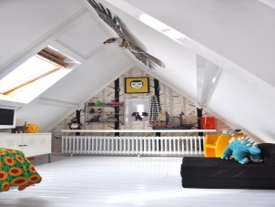 11.  What do we do in the …?  Dining room  Kitchen  Living room etc.  (1.In the dining room we eat.  2. In the kitchen we cook.  3. In the living room we relax and watch TV  4. In the bathroom we have a shower.  5. In the bedroom we sleep  6. In the swimming pool we swim  7. In the garage we leave our car.  8. In the garden we plant the flowers.)  While-listening task  Hello! My name is Peter and this is my house.  My house is quite big. It has got two floors: a ground floor and a first floor. It has also got an attic.  On the ground floor there is the hall , the kitchen, the living room, a big dining room and a toilet.  On the first floor there are three bedrooms, one bathroom and a long corridor. My bedroom is between my parents’ bedroom and the bathroom. My sister’s bedroom is in front of mine.  I love my bedroom, but I also like the attic. In the attic I keep some of my books and my old toys. I like to spend my time there because it is very spacious and there is a big sofa there where I sometimes take a nap.  At the behind of the house there is also the garage and a lovely garden, two swings and a swimming pool.  I love my house. It is very comfortable and light.  I’ll give you cards. Listen to the text and cross out the words from the text. Bingo  My house lamp a lovely garden  Clean quite big The first floor  Garage bathroom comfortable  Table lamp a lovely garden  Clean quite big The third floor  Garage bathroom Upstairs  My house lamp a lovely garden  Clean quite big The first floor  Light bathroom a ground floor  My house lamp a lovely garden  Clean quite big The first floor  Garage bathroom a ground floor  Attic lamp a lovely garden  Clean swings The first floor  Garage bathroom bedroom  Work in pair. Opposites of these adjectives.  You should write the opposites of the words. I’ll give you 5 minute.  Then you exchange your answers and check each other. I’ll show you right answers.  Small ( big)  New (Old )  Spacious (cramped )  Behind (front)  Comfortable (uncomfortable )  Short (long)  Dark (light)  Physical training. Let’s have a rest.  Post-listening task  Questions:  Is Peter’s house big or small?  How many floors are there?  Can you name the rooms on the ground floor?  Can you name the rooms on the second floor?  Has his house got an attic?  Why does he like to be in attic?  How many bedrooms are there in his house?  What else are there in the Peter’s house?  Does Peter like his house?  Individual work.  Several pupils describe their own fantasy home.
Feedback | What about today’s lesson?  What I got from the lesson?
Reflection | If you don’t understand the lesson put your card on the door.  If you understand the lesson good put your card on the window.  If you understand the lesson very good put your card on the roof.
Descriptor | Learners can:  Match the words with the pictures.  Listen to the text and cross out the words.  Find out the opposites of adjectives.  Answer the questions from the text.  Describe your fantasy home.

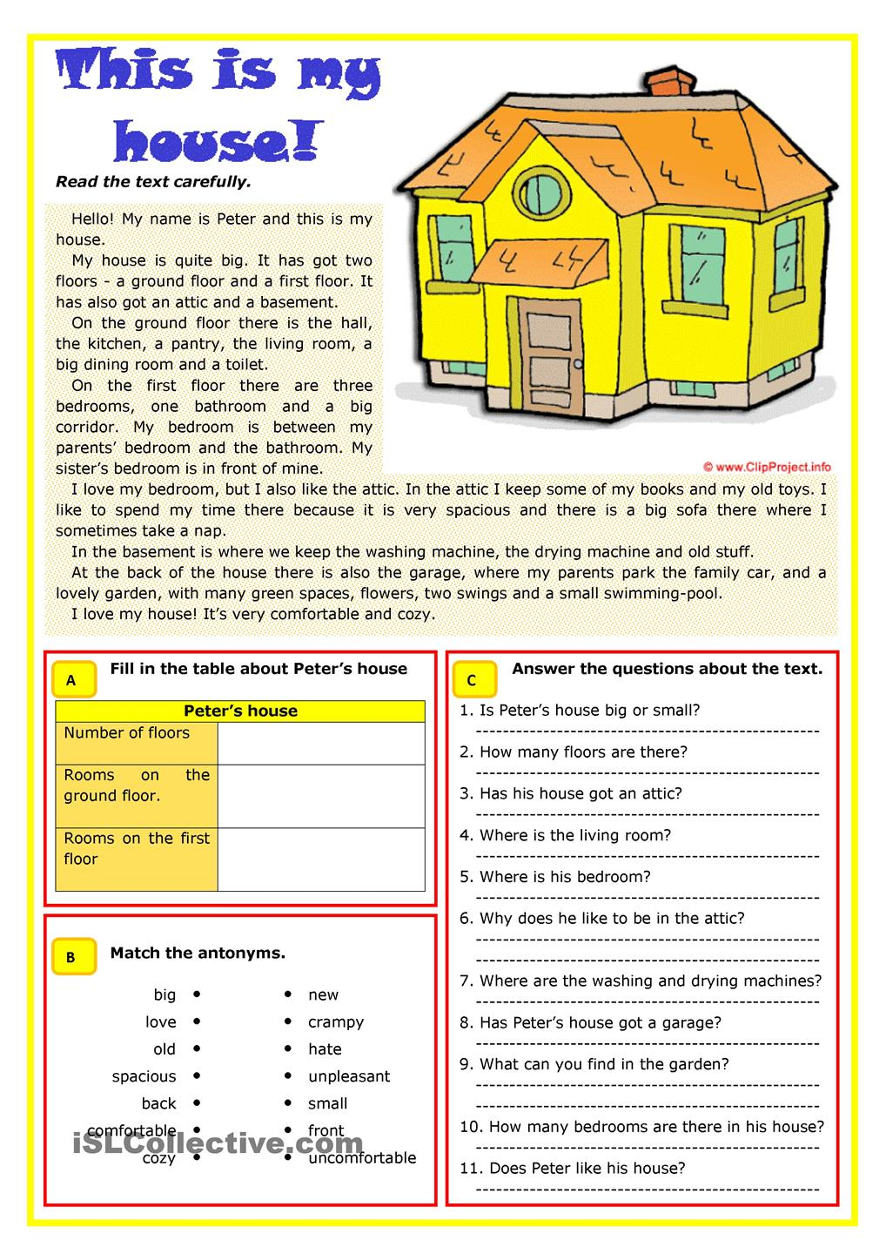

Home and garden 1  - Describing and designing rooms and furniture and talking and writing about them. | 1 | 5.L1understand a sequence of supported classroom instructions  5.L4 understand the main points of supported extended talk on a range of general and curricular topics  5.S6 communicate meaning clearly at sentence level during, pair, group and whole class exchanges  5.S7 use appropriate subject-specific vocabulary and syntax to talk about a limited range of general topics  5.S5 keep interaction going in basic exchanges on a growing range of general and curricular topics  5.W2 write with support a sequence of short sentences in a paragraph on a limited range of familiar general topics  5.C4 evaluate and respond constructively to feedback from others  5.W3 write with support factual descriptions at text level which describe people, places and objects  5.C10use talk or writing as a means of reflecting on and exploring a range of perspectives on the world  5.UE6 use basic personal and demonstrative pronouns and quantitative pronouns some, any, something, nothing anything on a limited range of familiar general and curricular topics  5.UE5 use questions, including tag questions to seek agreement, and clarify meaning on a limited range of familiar general and curricular topics  5.UE14 use prepositions to talk about time and location;  use prepositions like to describe things and about to denote topic; use prepositions of direction to, into, out of, from, towards  on a limited range of familiar general and curricular topics  5.R1 understand the main points in a limited range of short simple texts on general and curricular topics
Home and garden 2  - Describing and designing gardens and talking and writing about them | 2 | 5.L6 deduce meaning from context in short, supported talk on an increasing range of general and curricular topics  5.S6 communicate meaning clearly at sentence level during, pair, group and whole class exchanges  5.C8 develop intercultural awareness through reading and discussion  5.S7 use appropriate subject-specific vocabulary and syntax to talk about a limited range of general topics  5.W6 link, with some support, sentences into coherent paragraphs using basic connectors on a limited range of familiar general topics  5.C10use talk or writing as a means of reflecting on and exploring a range of perspectives on the world  5.W8 spell most high-frequency words accurately for a limited range of general topics  5.UE1 use appropriate countable and uncountable nouns, including common noun phrases describing times and location, on a limited range of familiar general and curricular topics  5.C7 develop and sustain a consistent argument when speaking or writing  5.UE8 use future forms will for predictions and be going toto talk about already decided plans on a limited range of familiar general and curricular topics  5.UE14 use prepositions to talk about time and location  use prepositions like to describe things and about to denote topic  use prepositions of direction to, into, out of, from, towards  on a limited range of familiar general and curricular topics

