Date:14.11.2019 School:K.Rysbekov
Form:3ә
Teacher/s name:Saydalieva Sh
Theme: «Days of the week»
The main aim of the lesson;
Educational: a) to develop student’s ability in speaking English language,
to revise vocabulary of days of the week, preposition, Present Simple.
Developing: а) to develop students’ skills and habits in speech
b) to develop students interest in the Subject of English
Unit organization:
I Org.moment
1.Greeting.
Good afternoon, children! I am glad to see you!
-How are you? I am fine, thank you!
Now you must stand in the circle and you must ask each other “How are you today?”
2.Warm up.
Now let’s play a game. Who will be a journalist?
Today the journalist decided to visit us and to get to know us. He asks the questions you must answer the questions. OK?
-What’s your name?
-How are you?
-How old are you?
-Where are you from?
-Where are you from in Kazakhstan?
Wonderful!!! Great!!!
ІІ Check h/w
Now we revise the words which you studied at the previous lesson:
To get up - тұру
To wash your hands and face – қолын бетін жуу
To have breakfast – таңғы асты жеу
To go to school – мектепке бару
To study - оқу
To have lunch – түскі асты жеу
To play with friends – достарымен ойнау
To do homework – үй жұмысын істеу
To watch TV – теледидарды қарау
To brush your teeth – тістерін тазалау
To go to bed – төсекке жату
To sleep – ұйықтау
In the morning – таңертен
In the afternoon – күндіз
In the evening – кешке
At night – түнде
Work in pairs (s-t).
-What time is it? – It’s 7 o’clock.
-What time do you get up? – I usually get up at six o’clock.
-What do you do on Sunday? – I usually play with my friends on Sunday.
Answer the questions:
- What do you do in the morning?
- What time do you get up?
- What do you do in the evening?
- What time do you go to school?
- What time do you sleep?

ІII Revision the theme.
The new vocabulary.
Remember!
Monday
Tuesday
Wednesday
Thursday
Friday
Saturday
Sunday
Days of the week
We use on with the days of the week: on Monday, on Friday
I go to school on Monday.
Ex.1 read and translate the text.

I want to divide you into three groups. I want to give you some sweets different colors. You must be separated by color: red, yellow, blue. And you must do some tasks.
M a r k s h e e t
№ | Pupils | Writing  жазу | Listening  тыңдау | Speaking  сөйлеу | Reading  оқу | Final mark  қорытынды баға
1.
2.
3.
4.

The tasks:
You should make up as many sentences as possible! Look at the screen. What do you usually do?

I | go to school | on Monday | in the morning  in the afternoon  in the evening  at night
 | watch TV | on Tuesday
 | do homework | on Wednesday
 | brush my teeth | on Thursday
 | have breakfast | on Friday
 | go to bed | on Saturday
 | play with friends | on Sunday
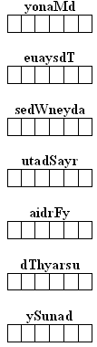
You must guess the day of the week:

– What day is between Sunday and Tuesday?
– What day was yesterday?
– What day is between Tuesday and Thursday?
– What day will be tomorrow?
– What day comes after Thursday?
– What day comes before Friday?
– What day comes before Monday?

Look at the pictures. Your task is using the word cards to remind children to make up sentences by using them
Finish the sentences with the pictures:
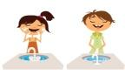
1)I usually at 7 o’clock in the morning. 2) We 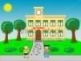 at 2 o’clock in the afternoon.

3) He at 9 o’clock at night. 4) You at 5 o’clock in the afternoon.

5) They 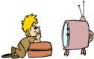 at 6 o’clock in the evening. 6) I at 10 o’clock in the morning.

Physical exercise.
Stand up, sing a song with me and do some exercises.

Tasks:
1.Complete the dialogue
1. you/what/time watch TV/do?
_______________________________
2. what/you/time/have breakfast/do?
_______________________________
3.you/what/time/go to bed/do?
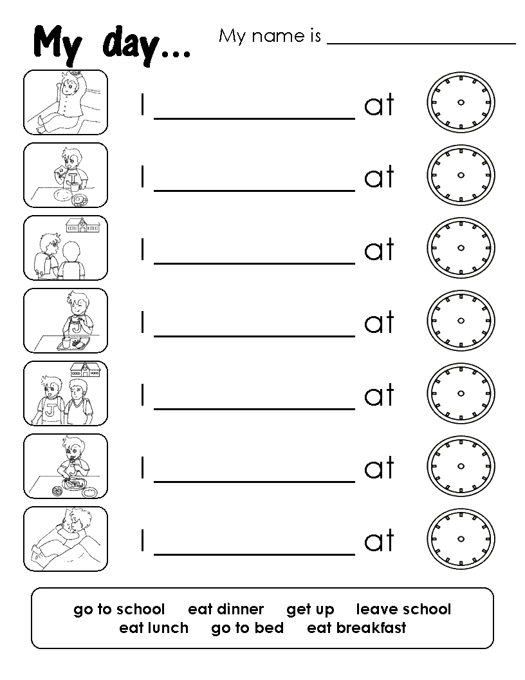
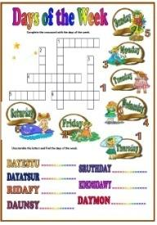
_______________________________
4.what/time/you/do/go to school?
_______________________________
2.Crossword.
3.Make the sentences.
IV The end of the lesson.
What did we talk about?
What the new words did you have today?
H/w.
Open your diaries and write down the home task. Your home task will be learn 7 days of the week and complete the sentences.
Total.
You were very active today at the lesson. You’ve worked hard today and I got you only good and excellent marks for today lesson.
Thank you! Good Bye!

1.My activity at the lesson:
1. 2. 3. 4. 5.
2.I could encourage my friends:
1. 2. 3. 4. 5.
3.How I understood the lesson:
1. 2. 3. 4. 5.
4.The lesson was interesting:
1. 2. 3. 4. 5.

